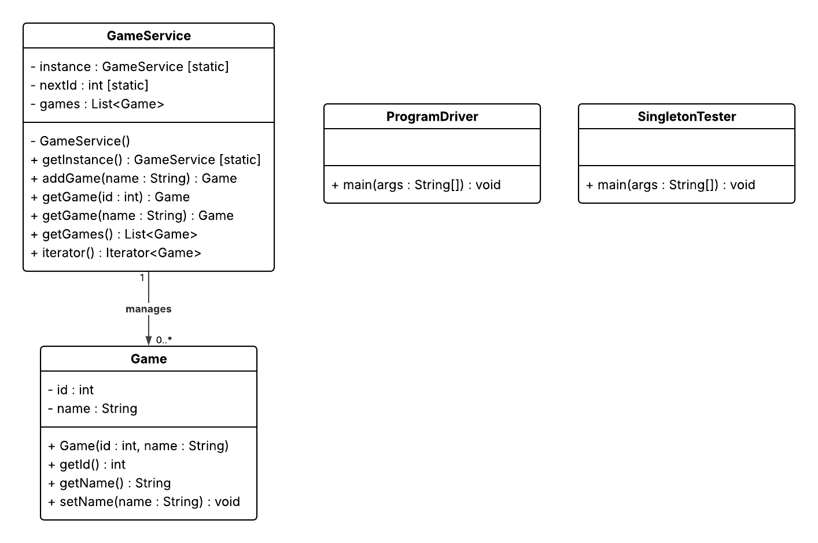

The singleton pattern is used in the GameService class to ensure only one instance of the service can exist in memory at any time. By making the constructor private and exposing a static getInstance() method, all parts of the program share the same service object. This guarantees that all games are created and managed through a single point of control, avoiding duplicate or conflicting data. In the context of this application, the singleton ensures consistency when tracking games across both the driver and tester classes.

Project Two Evaluation
The following evaluation compares Linux, Windows, macOS, and mobile platforms in terms of server hosting capabilities, advantages, weaknesses, and licensing costs. These findings are meant to inform The Gaming Room about how the game application could be deployed and scaled.
Platform | Server hosting capability | Advantages | Weaknesses | Licensing costs (OS) | Notes
Linux (Ubuntu, RHEL, etc.) | First choice for web servers. Mature HTTP stacks, strong container support, scales horizontally. | Stable, secure, excellent package repos, strong DevOps ecosystem, great performance per dollar. | Requires Linux admin skills, package diversity can create drift if not standardized. | No OS license cost for most distros. Enterprise support is optional. | Ideal for autoscaling with Docker and Kubernetes. Pairs well with Nginx, HAProxy, PostgreSQL, Redis.
Windows Server | Fully capable IIS or reverse proxy hosting. Good .NET support. | Strong AD integration, familiar to Windows-centric teams, first-class .NET runtime. | Proprietary, heavier resource footprint in many setups, fewer Kubernetes-first patterns. | Proprietary Windows Server licenses. | Consider if the team and tooling are .NET and Windows focused.
macOS | Technically possible but uncommon for production web hosting. | Useful for development and CI that targets Apple platforms. | Not typical for production servers, limited hosting options, hardware constraints. | Proprietary macOS license tied to Apple hardware. | Treat as developer workstation or CI runner, not as a production server.
Mobile (Android, iOS) | Not used as server hosts. | N/A for hosting. | N/A for hosting. | N/A for hosting. | These are client targets that consume the web app via HTTPS APIs.

Client-Side Considerations
The client application must support responsive HTML5 for desktop browsers (Linux, macOS, Windows) and also run on Android and iOS devices. Developers need to ensure consistent use of the REST API, design responsive layouts, and follow accessibility standards. Cross-platform frameworks such as React Native or Flutter reduce time and cost by supporting both mobile platforms from a single codebase, though they require specialized skills. Native development in Kotlin (Android) and Swift (iOS) provides the best integration with device features but increases cost and effort since two separate codebases must be maintained.
Development Tools
Server development can be handled with languages such as Java (Spring Boot), Node.js (Express), or Python (Flask or Django). Client development may use React, Vue, or Angular for the web, and React Native or Flutter for mobile. IDEs include IntelliJ IDEA, VS Code, Android Studio, and Xcode. Licensing costs are generally low, though Apple requires a paid developer account for App Store distribution and IntelliJ IDEA has a paid edition. Team structure depends on the toolset: a single team can cover server and web development, but native mobile development often requires separate Android and iOS specialists.

Recommendations
For the server operating platform, Linux is the most appropriate choice for expanding Draw It or Lose It into other computing environments. Linux is widely adopted for hosting web applications, offers strong security, is cost-effective due to its open-source licensing, and provides excellent support for scalability through containerization tools such as Docker and Kubernetes.
The Linux operating system architecture is modular and stable, built around a monolithic kernel that manages core services including process scheduling, memory management, file systems, and device drivers. Its support for POSIX standards ensures compatibility across environments. Linux also provides efficient multitasking and robust networking capabilities, making it suitable for handling thousands of concurrent players.
For storage management, a distributed storage solution such as cloud-based object storage or a network-attached storage system can be used. This ensures redundancy, scalability, and fast access to the 200 high-definition images required by the game, along with user data and logs. File system options such as ext4 or XFS on Linux are reliable for high-throughput workloads, while databases such as PostgreSQL or MySQL can handle persistent user and session data.
Linux uses virtual memory management techniques such as paging, segmentation, and demand loading. These techniques ensure that memory is allocated efficiently and reclaimed when no longer needed. For Draw It or Lose It, images can be streamed into memory only when required, while caching and garbage collection prevent performance degradation. This approach provides rapid rendering while keeping memory use under control across client sessions.
Distributed systems will be critical for supporting multiple platforms and ensuring seamless gameplay. The application can be deployed in a client-server architecture with REST APIs, where the server handles game logic and multiple clients (Android, iOS, desktop browsers) interact over the network. Load balancers can distribute requests across multiple servers, while redundancy ensures high availability even in case of outages. Networking protocols such as HTTPS will provide secure, reliable connections between distributed components.
Security must be integrated at every layer. User data should be encrypted both in transit (TLS/HTTPS) and at rest (AES or equivalent). Authentication and authorization can be managed through token-based systems such as OAuth 2.0. Linux provides role-based access controls and firewall configurations to limit access to critical resources. Regular updates, intrusion detection systems, and monitoring further strengthen defenses against attacks.
By combining Linux as the server platform with distributed architecture, scalable storage, efficient memory management, and strong security practices, Draw It or Lose It can successfully expand to multiple operating environments while maintaining reliability, performance, and user trust.

